Hand Held Liquid & Metal Detector

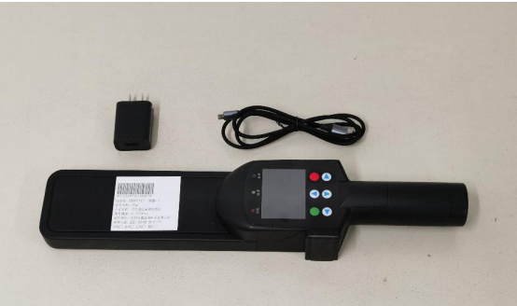

Product Description
The handheld hazardous liquid metal (two-in-one) detector is a security inspection instrument specially used to detect flammable, explosive, corrosive liquids and metals. It uses the principle of detecting small capacitance changes in the outside world through a computer, and determines its flammability and explosiveness based on the dielectric constant and conductivity difference of the liquid to be measured. The detector can distinguish flammable and explosive liquids such as gasoline, acetone, and ethanol from safe liquids such as water, cola, milk, and juice without direct contact with the liquid. When using this method to detect liquids, please select a flat and uneven wall portion of the container for testing. It also has the function of detecting metal objects, can detect all metal types, has buzzer alarm, LED signal strength indication and vibration alarm functions.

Function Description
Detectable types | Gasoline; diesel; CH3NO2; C2H4Cl2; toluene; benzene; C6H5NO2; acetone; methanol; ethanol; ethylene glycol; ether; (CH3)2CHOCH(CH3)2; rosin water; paint thinner (nitro thinner solvent) kerosene, etc. Various hazardous liquids
Sampling method | non contact sampling
Alarm mode | Sound, light alarm and color LCD screen pattern alarm mode
Start Time | ≤2 seconds
Detection time | ≤1 second
The maximum wall thickness of the container that can be detected | 5mm non-metallic container
The effective distance between the detector and the side wall of the container | Within 3mm
Detection level | A
False alarm rate | ≤1%
Automatic counting | ≥5000

Product Performance
Size | 385mm(length)×50mm(width)×80mm(height)
Weight | About 500g (including battery)
Screen | 2.5 inches
Operating environment | Temperature: 0～+40℃, humidity: 0～99%RH (no condensation) Temperature: 0～+40℃, humidity: 0～99%RH (no condensation)
Operating hours | Work continuously for 8 hours

Application
This instrument can be widely used in security inspection, preventing terrorist attacks, preventing fires and other fields.
Transportation department: railways, stations, airports, subways, ports, etc.
Government departments: embassy, police station, fire station, court, prosecution, border station, military, etc.
Public places: large conference venues, stadiums, theaters, shopping malls and other crowded places.
The detector does not contain ions, microwave radiation sources and other potentially dangerous elements, and is safe and harmless to operators.

