Handheld Through-the-Wall Radar Life Detector | GA700
Description
This ultra-portable tactical device leverages advanced Ultra-Wideband (UWB) and Stepped-Frequency Continuous Wave (SFCW) radar technology to penetrate non-metallic barriers such as brick, concrete, and wooden structures. It enables real-time, non-contact detection and monitoring of living subjects hidden behind walls, providing operators with immediate feedback on human presence, distance, and subtle movements like breathing. With robust signal processing algorithms, the system maintains high detection accuracy and minimal false alarms even in complex, cluttered environments.

Weighing only 1.3 kg and featuring an intuitive interface, the radar supports flexible operational modes including stand-off scanning and synchronized multi-unit deployment. It is an essential tool for military reconnaissance, counter-terrorism operations, law enforcement raids, and emergency rescue missions. By delivering critical situational awareness and revealing concealed threats, the device empowers personnel to execute missions with enhanced safety, precision, and operational confidence.
Features
- Compact and Lightweight: Weighs only 1.3 kg.
- High Penetration Capability: Can effectively penetrate solid brick walls up to 50 cm thick.
- Long Detection Range: Detection distance up to 30 meters.
- Excellent Detection Performance: High detection accuracy with low false alarm rate.
- Non-Contact Operation: Can detect without direct contact with the wall.
- Multi-Device Synchronous Operation: Multiple units can operate simultaneously without mutual interference.
- Wireless Remote Control: Supports wireless remote operation.
Applications
- Hostage Rescue
- Counter-terrorism Operations
- Urban Warfare / Urban Operations
- Intelligence Gathering
- Reconnaissance and Surveillance
- High-risk Apprehension / Tactical Arrest
- Narcotics Enforcement Operations
- Search and Rescue Operations

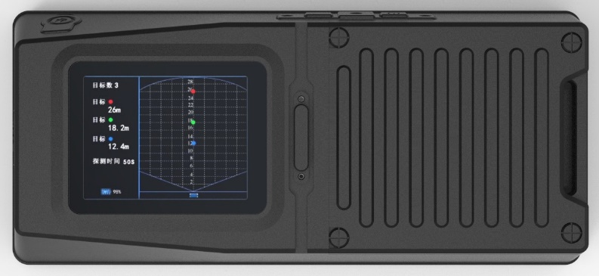

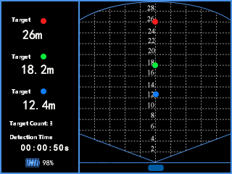

Parameter
Device Type | Handheld Through-the-Wall Life Detection Radar
Maximum Penetration Thickness | Brick wall: ≥ 50 cm
Number of Walls Penetrable | No less than 2 walls
Maximum Detection Range | Static Target： ≥ 25 m
Maximum Detection Range | Moving Target： ≥ 30 m
Maximum Number of Targets | 3
Detection Angle | Azimuth and elevation angle not less than 100°
Display Screen | Color LCD
Display Mode | Graphic + Text + Numeric Values
Target Information | Target presence, number of targets, target distance, detection time
Resolution | Better than 0.3 m
Power Supply Method | Rechargeable Lithium-Ion Battery
Battery Endurance Time | Not less than 4 hours
Wireless Functionality | Yes
Temperature | Operating Temperature: -20°C to +55°C  Storage Temperature: -40°C to +60°C
Dustproof & Waterproof | IP65
Dimensions | Length: 227mm, Width: 108mm, Thickness: 105mm
Weight | 1.3 kg

Packing List
No. | Item | Quantity | Optional
1 | GA700 Handheld Through-Wall Radar Life Detector | 1 unit | Standard
2 | Charger | 1 set | Standard

