User manual
---------CBM1Z2LE

1. Scope of application
CBM1LZ series of intelligent residual electrical action circuit breaker (referred to as leakage circuit breakers) is the company in recent years research and development, superior performance,fast to operate the latest generation of leakage circuit breaker
personal electric shock hazard, and to protect earth fault, over current and short circuit of line or electricity, etc .
Meet the standard: 14048.2.

2.Multi-functional features
This product have three types .
Ordinary type, Electronic adjustable type, communication type .
2.1
Common type with adjustable residual current, auxiliary power over voltage, phase failure, over current, short circuit protection and automatic reclosing, voltage display.Residual current display, leakage alarm does not trip, action status indication and other useful features.
2.2
Electronic adjustable type is the above function also increases the current can be set function, the digital tube can display three phase
load current, in actual electricity, the double root according to the data tube shows the size of the load to set the circuit breaker
current setting.
2.3
Communication: customized according to customer requirements (see the fourth page of the table)
Shape and panel functions and installation dimensions
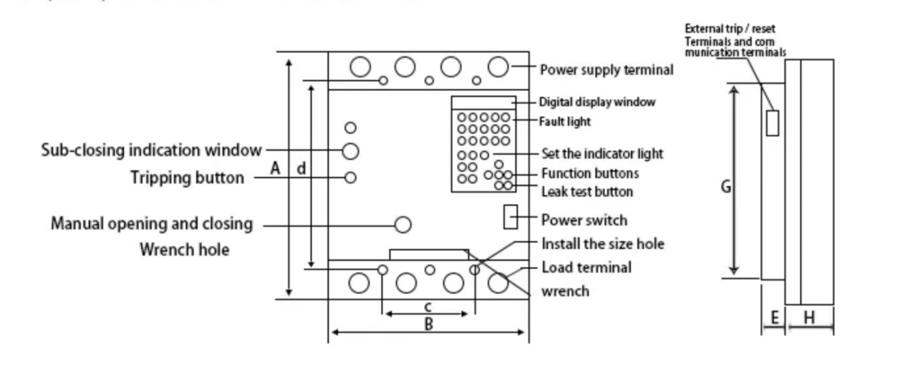
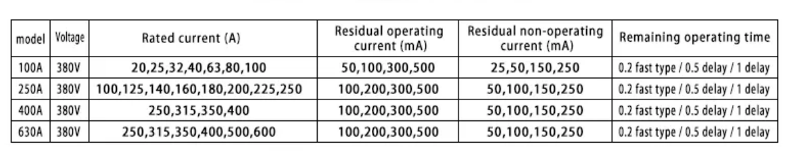

3.Normal operating conditions
3.1Ambient air: -5 C +40 ℃ .
3.2Humidity: When the maximum temperature of +40 ℃ , the relative humidity of the air does not exceed 50%, When the temperature is 20 ℃ to allow up to 90%;
and taking into account the temperature changes occur occasionally in the production surface of the condensation.
3.3Altitude not exceeding: 2000 meters.
3.4Pollution level:3.
3.5Installation category: II.
3.6Power sine wave distortion less than 5%.
3.7The installation site in any direction where the magnetic field does not exceed 5 times the geomagnetic field. No explosive, corrosive gases; no rain and snow invasion; dry, ventilated.

4.Product model number and its meaning

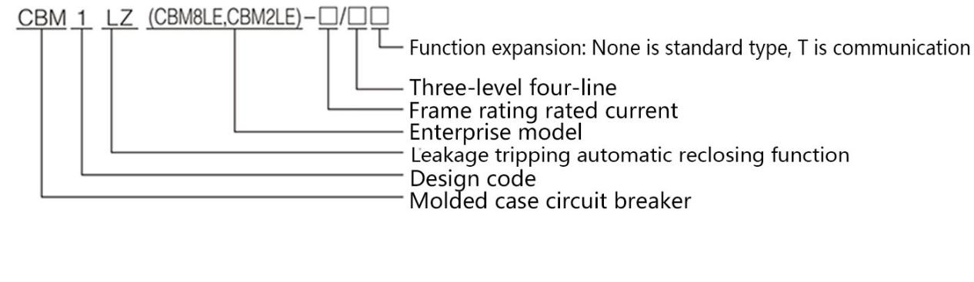

4.Technical Parameters
4.1 Rated voltage: 380V three phase four-wire
4.2 Rated current:
100A Housing: 40A 63A 80A 100A can be set;
250A Housing: 63A 100A 125A 140A 160A 180A 200A 225A 250A can be set;
630A (400A) Housing: 250A 315A 350A 400A 500A 630A can be set;
800A Housing: 630A, 800A can be set
4.3 Rated frequency: 50Hz
4.4 Rated residual operating current (mA): 0.05 / 0.1 /0.2/ 0.3/ 0.5 can be set
4.5 Rated residual non-operating current (mA): 0.025 /0.05 /0.1/0.15 /0.25
4.6 Rated residual breaking time: <0.2s / 0.5s S type/ 1s S type
4.7 Time delay reclosing time: 20-60s automatic reclosing time
4.8 Auxiliary power under voltage action value: single-phase 168V土5% (voltage to resume normal automatic closing)
4.9 Auxiliary power over-voltage action value: single-phase 270V土5% (voltage returns to normal after the automatic closing)
4.10 Leakage action characteristic classification: AC type
4.11 Product use category: Class A
4.12 This product complies with: GB140480.2

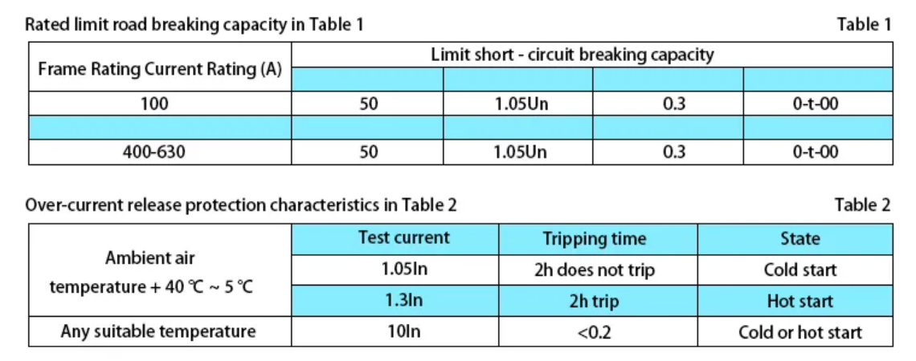

5.Product installation and function setting role
5.1 Before the installation, the leakage circuit breaker power switch in the "off" position! A green word "separate" is displayed in the opening and closing indication window.
5.2 .The product should be mounted vertically and fixed with screws through the mounting holes.
5.3 According to the product rated current , selecting the appropriate wire from the standard (Table 3) to connect the wires strictly.
Terminal 1,3,5, N on the circuit breaker is for the main circuit power supply side,
Terminal 2, 4, 6, N on the circuit breaker is for the load outlet.
Wire must be connected with the copper wire access,
After wiring is completed, please install the arc plate.
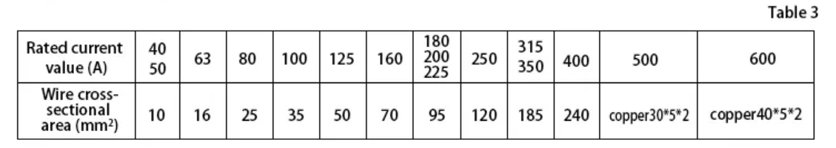
5.4 Leakage circuit breaker closing operation
5.4.1 Turn the power switch on the earth leakage circuit breaker to the "on" position. Digital display, "power "indicator light is on , after 20s-60s , the electric closing mechanism automatically close the Leakage circuit breaker, splitting display window shows the red "together."

5.4.2If the earth leakage circuit breaker is in the separate state, and do not close
the power switch of the earth leakage circuit breaker, Please inserting the hexagon socket wrench on the panel into the screw hole of the manual power switch of the earth leakage circuit breaker, Turn the hexagon socket wrench clockwise , until the switch is closed
splitting display window shows the red "together."
(In the case of closing the motor is damaged, normal The situation generally do not need to operate).
5.4.3
When the leakage circuit breaker is working normally , you can use external terminals 3,4 control the switch , if 3,4 is off, the leakage circuit breaker re-automatic closing, splitting display window shows the red "together."

5.5Leakage circuit breaker disconnection operation
5.5.1
How to disconnect the Leakage circuit breaker when it is working .
Inserting the hexagonal screw wrench into the "manual closing" screw whole , turn the wrench clockwise until splitting display window shows the green "separate."
5.5.2
How to disconnect the Leakage circuit breaker when it is working .
Press the "T" button, leakage circuit breaker is off immediately . splitting display window shows the green "separate."
leakage Electric indicator light is on . leakage circuit breaker will reclosing once automatically .

5.5.3
connect terminal" 3,4, leakage circuit breaker is off , splitting display window shows the green "separate."

5.6
Settings and displays
5.6.1Current setting : the power switch is in the on state, press the "set" button , until the the rated current LED is flashing, then press “+ -” Key, flashing LED will go with it,
move the current to the one you need to set, press the "confirm" button, LED light does not flash set successfully, press "Exit” Key to return to the normal display.
5.6.2 Residual current setting: the power switch is in the on state, press the "set" button, until Residual current LED light is flashing, and then press the "+ - " key to move left or right,
Press the "OK" button, LED lights do not flash set successfully, press the "Exit" button to return to normal display.
5.6.3 The remaining operating time is set according to the method above.
5.6.4 Leakage (slow) automatic tracking function settings : the power switch is in the on state, press the "Settings" button , until the Auto -Tracking feature LED is flashing, press "+ - " key to move on and off, select "On"or "off", press "confirm" button, LED light does not flash . Press "Exit" button to return to normal display.
In the automatic tracking, according to the slowly change electric leakage in the circuit automatically increase or decrease the Residual current setting , achieve the value of the Residual current setting tracking function,If the electric leakage is over the setting value suddenly , leakage circuit breaker will immediately off, leakage circuit breaker will reclosing once automatically .
5.6.5 leakage alarm but does not off , phase protection, according to the same method above to set.
Note, open the leakage alarm but does not off must be approved by the design department or the power supply authority , only then can be opened.
5.6.6 query records: the power switch in the on state, press the "+ - query" key,
the first two digits shows the fault order , they are like this E0,E1,E2 ,....EF , 16times in total .
The last three digits shows the fault value status and which phase.
Fault code
Ld stands for leakage,
dL for short circuit,
qLfor over current, qY for under voltage, and dI for zero.
A, B, C, N fault that state A phase, B phase, C phase, N phase fault.
LDA means , electric leakage in phase A .

5.6.7 5 seconds after closing, press the "T" key, it will reclosing after 20s-60s ,
If you want to press "T" key again , you must turn on and off the switch once or wait after two minutes , otherwise press "T" key, the circuit breaker will be self-locking, and can not automatically reclose.
5.6.8 when the residual current over the action value, the circuit breaker will immediately
Off , and reclosing once , if the value is still over , the circuit breaker will off again , and self-locking, can not automatically reclosing, after excluding short-circuit fault, open and
close leakage circuit breaker power switch once, the function will be same as usual .
5.6.9 Overload or short-circuit , “Overload” or “short-circuit” light is on can not automatically reclosing, have to excluding short-circuit fault first , then open and close leakage circuit breaker power switch once , it will then reconnect .
5.6.10
Under voltage, phase loss, zero fault trip, "under voltage" "phase" "zero" indicator light is on , can not automatically reclosing, have to excluding short-circuit fault first , then open and close leakage circuit breaker power switch once , it will then reconnect .
5.6.11
Check the extra terminal through the label.
1,2 terminal is for communication
When terminal 3,4 is on , the circuit breaker will be off .
When terminal 3,4 is off , the circuit breaker will be on .
terminal 5,6,7 is the leakage and any other fault alarm contacts,
in normal working condition , 5,6 normally open, 6,7 normally closed, if there is leakage and any other fault , 5,6 normally closed, 6,7 in the normally open.
Note: External terminals have been powered inside, do not connect outside power to these terminals . Otherwise it will damage the Electric circuit breaker.

Panel display

Working state | 5 digits display |  |  |  |  | Meaning
Under normal circumstances, each state is displayed in a cycle for two seconds each | U | A | 0 | 0 | 0 | Real time voltage of phase A
 | U | B | 0 | 0 | 0 | Real time voltage of phase B
 | U | C | 0 | 0 | 0 | Real time voltage of phase C
 | I | A | 0 | 0 | 0 | Real time current of phase A
 | I | B | 0 | 0 | 0 | Real time current of phase B
 | I | C | 0 | 0 | 0 | Real time current of phase C
 | L | D | 0 | 0 | 0 | Real time Residual current

Common problems and solution
Problem  Type | Problem like | Reasons might be | solution
Product can’t work | Switch on , display doesn’t show | Circuit breaker is damaged | Change for a new one
Product can’t work | Switch on , display shows ,  but switch can’t not Auto-reclosing | Auto-reclosing motor is damaged | Change for a new one
Product can’t work | Auto-reclosing motor is moving , but switch is still off | Auto-reclosing motor is damaged | Change for a new one
Product can’t work | “Power” light flashing , the switch can’t not be on | Power source weird | Check the volt of the three phase four wires .
Product can’t work | After close the switch , the switch is off immediately , and the display shows the current is over the limits | The electric circuit is overload or Neutral wire is double connected ; or circuit is misconnected . | Check the circuit wires .
Product can’t work | Press the “T” button , it does not Auto-reclosing | Time is too short since last time you press it . | Check 5.6.7
Switch  Can’t  Move | Press the “T” button ,the switch does not go off | Voltage is too low in the circuit or the Circuit breaker is damaged . | Check the circuit wires . or Change for a new one
Switch  Can’t  Move | Press the “T” button ,the switch goes off , but the LED light testing in real place , the switch does not go off | ground wire is not connected well | Check the ground wire
Switch  Can’t  Move |  | The actual current has not reach the tripping point | Use higher watts light testing .

